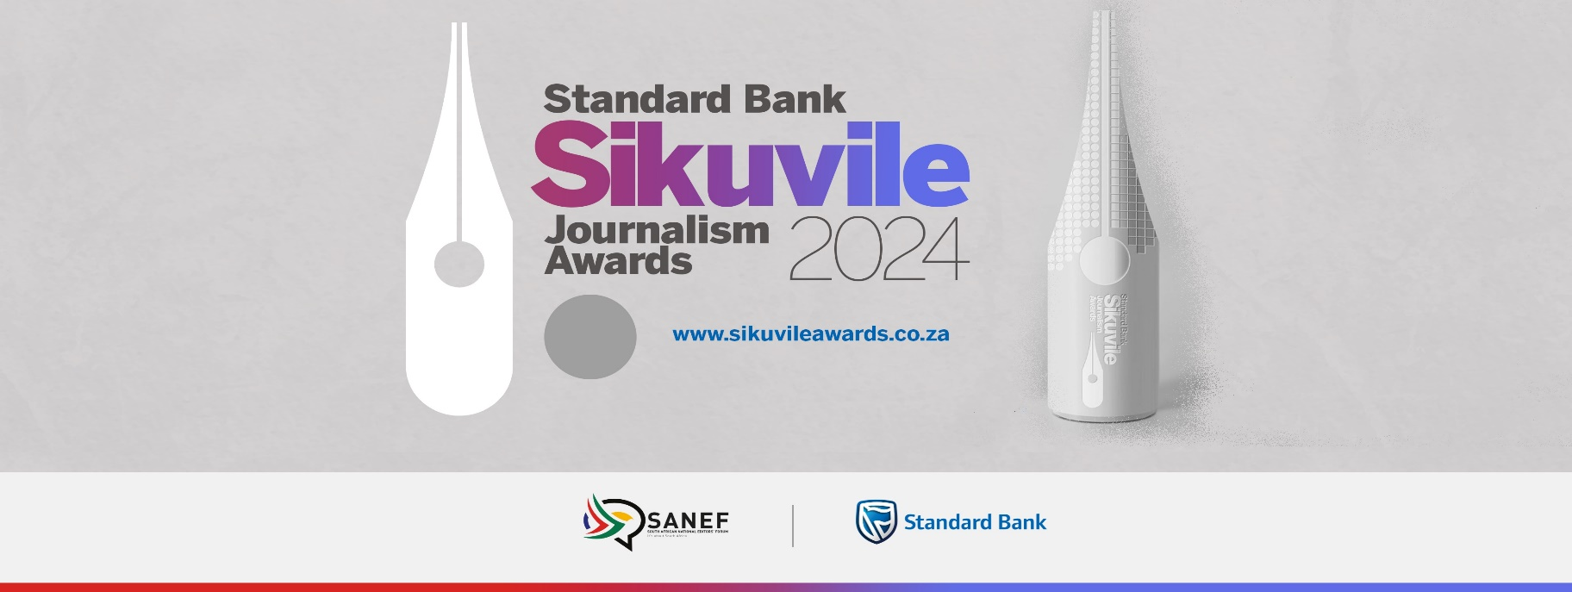

Entrant’s declaration
I, the entrant, declare that the work submitted by me as an entry into the Standard Bank Sikuvile Journalism Awards was produced by me, qualifies as an entry and I have permission to submit it.

My (the entrant) name:

My (the entrant) signature:

Editor’s declaration:
I, the Editor, declare that the work submitted by the above entrant as an entry into the Standard Bank Sikuvile Journalism Awards appeared in my publication/platform and has permission to submit it.

My (the Editor) name:

Name of publication/platform:

My (the Editor) signature:

